NAME: DATE:
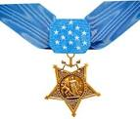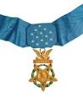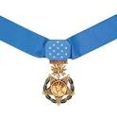
MEDAL OF HONOR INFOQUEST
DIRECTIONS: USE THE WEBPAGE http://www.cmohs.org for information to answer the following questions. Use the entire website for information. The headings (HOME, THE MEDAL, ETC.) all have drop down links.
1. In what year was the Medal Of Honor (MOH) created?
2. The MOH is the highest award for what?
3. How many total recipients have there been?
4. Has a woman ever been awarded the MOH? What is her name?
5. Who was the first person (recipient) to receive the MOH?
6. How many designs are there today?
7. Which war had the highest number of recipients?
8. Over 600 medals were awarded posthumously. What does posthumously mean?
9. Who was the first African American recipient?
10. How many Native Americans have received the MOH?

